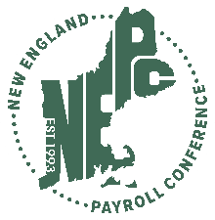 | 2026 New England Payroll Conference Education Grant Application

Complete this grant application and email a PDF copy to nepcgrant@nepaycon.org

Full Name:
Email Address:
Phone Number:
Company:
Job Title:

Type your responses in the box below the criteria. Please note, the box will expand as you type into it.

10 Points – Letter of recommendation
Signed and in PDF specifically addressing why the applicant is a worthy candidate for this grant. Please ensure the letter is no more than 2 years old.

25 Points – Educational achievements
What have you done to expand your payroll knowledge? Professional certifications, training courses, future goals for professional development.

25 Points - Professional Accomplishments
Projects as a lead or team member that have delivered cost savings, efficiencies, productivity improvements and/or overall improvements for your job, department or organization.

20 Points - Personal Accomplishments
Teaching payroll education within the community, mentoring within your organization or community, PayrollOrg engagement at a National or Local level, volunteer work (does not need to be payroll related).

20 Points - Personal Essay
If awarded the education Grant, describe how it would help you in the advancement of your professional career.

Once completed, print or save to PDF and email the application along with your letter of recommendation to the email address listed above.

